Smart Grid Technologies

Question 1
An industrial complex runs an isolated 4-node system as shown in Figure 1. The system is connected with 2 customer loads and 3 customer generators (i.e. Gen A, B and C) with different ratings and marginal fuel costs. Loads are connected at bus 3 (280 MW) and bus 4 (420 MW). The rating and impedance of each circuit is listed in the table below.
Line | X (p.u.) | Capacity  (MW)
1-4 | 0.100 | 420
2-3 | 0.175 | 350
2-3 | 0.175 | 350
2-1 | 0.250 | 420
3-4 | 0.350 | 500
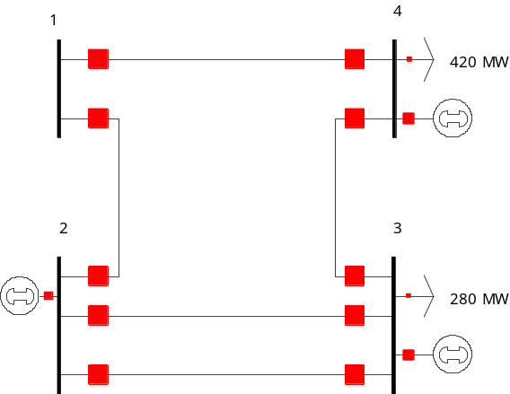
Gen C:
Rating: 200 MW
MC: £60/MWh
Gen B:
Rating: 50 MW
MC: £100/MWh
Gen A:
Rating: 650 MW
MC: £25/MWh

Figure 1 A 4-node system

- Determine the economic dispatch, which minimizes the operating cost. [2]
- Calculate the flows at each line. [3]
- If the system should withstand against single unplanned line outage, carry out contingency analysis and determine the critical contingency. [4]
- In order to operate securely in preventive mode, determine how generation output should be re-dispatched. [4]
- Calculate the cost of security. [2]
- In order to reduce the operating cost, the system operator decides to install a Quadrature-booster. Identify optimal location for installing the Quadrature-booster and the setting (phase angle) of it. [5]

Question 2

a. Provide definitions for CML and CI. What are typical CML and CI values for UK distribution networks?
[3]

Consider a section of a distribution network that serves 3000 customers. The table below lists the outage events that occurred on this network in 2015.

Customers affected | Duration
200 | 3 hours
500 | 10 minutes
1500 | 2 minutes
100 | 2 hours
20 | 2 days
300 | 30 minutes
1000 | 1 hour

b. Compute the CML and CI values for this section of the network.
[3]

Consider the following distribution network.
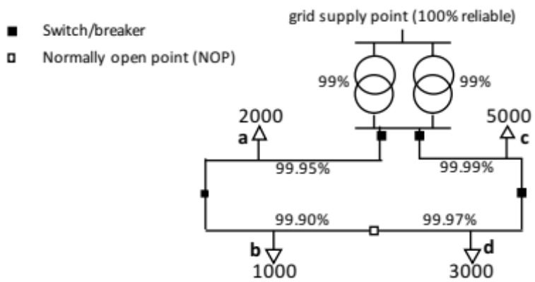
The load points (a-d) are labelled with the number of customers connected to each load point. The maximum diversified load is 1kW per customer, at 0.85 load factor. The capacity of each transformer is 15MVA. The availability of each component (transformer, feeder section) is listed alongside it as a percentage. Component failures are assumed to be independent and last more than 3 minutes each. The network is radially operated, but the normally open point (NOP) provides a degree of redundancy: the NOP is normally open, but it can be closed to resupply (b) or (d) in case of an upstream fault in the feeders at (a) or (c). You may assume that the normally open point reroutes power within 3 minutes.
The customers are a mixture of residential and SME customers, according to the table below. The customer interruption costs are £10,000/MWh for residential customers and £35,000/MWh for SMEs, and their average power consumption during outages is 0.4 kW (residential customer) and 2.5 kW (SME customer).

Load point | Residential customers | SME customers
a | 1900 | 100
b | 1000 | 0
c | 4700 | 300
d | 2700 | 300

c. Derive expressions for the probabilities that each of the the load points is connected to the grid supply point (one expression for each load point). Then compute the expected CML value for this network.
[7]

d. Compute the expected annual cost of interruptions under these assumptions, using the load point supply probabilities in computed in (c).
[4]

e. Explain the Willingness-to-Pay and Willingness-to-Accept approaches to evaluating customer interruption costs. Do you expect similar values when using WTA and WTP? Which approach do you think is more suitable as a basis for interruption costs models? Motivate your answers.
[3]

Question 3

a. The reliability of a 5km underground cable is modelled as a repairable two-state system. Its failure rate is 0.023/km/year and its availability is 0.9998. What is the mean time to repair?
[3]

Consider an automated monitoring and control system that has two failure modes: (1) a ‘soft’ failure that is automatically detected and rectified by reinitialising the system; (2) a ‘hard’ failure that requires a field visit by an engineer. We will model this process as a Markov chain with 3 states and the following transition rates: soft failure rate: 1in 20 days; hard failure rate: 1 in 230 days; recovery rate from soft failure: 0.5 per hour; hard failure repair rate: 0.5 per day.

b. Draw the corresponding continuous-time Markov chain model, using consistent units (hours or days) for all transition rates.
[2]

c. Derive a discrete time Markov chain for this process, assuming a time step of 1 hour. Draw it, including all non-zero transition probabilities. Do you think that the discrete time Markov chain with a time step of 1 hour is a good approximation of the continuous time process? Motivate your answer.
[3]

Consider a demand aggregator that controls the load of a portfolio of customers (large electricity consumers). It uses this controllability to offer a load shedding service to National Grid. When activated, an incoming load shedding signal from the National Grid control room is processed by two redundant computer systems. The computers then select appropriate loads to shed and send the necessary instructions over separate communication links. There is one communication link per customer, but this link is shared between both computer systems. Assume that the load shedding signal is sent to two customers.

To model the reliability of this system we will assume that the National Grid load shedding signal is 100% dependable. All other components (computer system, communications links, load shedding equipment at customer premises) are modelled as repairable systems. Failures are assumed to be independent.

d. Draw a reliability block diagram for the successful load shedding of both customers.
[2]

e. Draw a reliability block diagram for the successful load shedding of at least one of the two customers.
[2]

f. Assuming an availability of 98% for each component, quantify the probability of success for each of the diagrams in (d) and (e).
[2]

Monte Carlo methods

g. What is the formula for the Monte Carlo estimator for the risk $R=E[X]$, using $N$ samples of the random variable $X$?
[2]
A snapshot Monte Carlo simulation is used to estimate the expected cost of interruptions. After N=10,000 samples the best estimate of the cost is £108,762, with a standard error of £2581.
h. How many samples will be required (approximately, in total) to reduce the standard error of the mean to £1000?
[2]

i. How many samples will be required (approximately) to reduce the width of the 95% confidence interval for the mean to £1000?
[2]

Question 4

Part I: Flexible Demand
a) Explain the principles of centralised and price-based scheduling of flexible demand appliances. What are the advantages and disadvantages of each of these approaches? [4]
b) A simple power system, operating at a two-hour horizon, includes:
- a generator producing power $s_{t}$ (MW) at hour $t$ with a cost function $C_{t}\left(s_{t}\right)=50s_{t}^{2}$ (£) and a maximum output limit $s^{max}=10$MW
- inflexible demand appliances, consuming power $D_{1}=3$MW (at hour 1) and $D_{2}=2$MW (at hour 2)
- 1000 identical flexible demand appliances with continuously adjustable power $d_{t}$ (kW), scheduling interval including hours 1 and 2, total energy required $E=5$kWh and maximum power limit $d^{max}=5$kW
i) Under centralised scheduling, what is the optimal power demand of each of flexible demand appliances at each of the two hours? What is the total generation cost?
[2.5]
ii) Assuming that price-based scheduling is employed, what should be the relation between the prices at hour 1 and 2 (denoted by $λ_{1}$ and $λ_{2}$ respectively)? What is the resulting power demand of each of the flexible demand appliances? What is the total generation cost? Is it higher or lower than the total generation cost calculated in i)? Why it is higher or lower?
[3.5]
Part II: Big Data
a) List the primary sources of big data in power systems [2]
b) Briefly outline three big data analysis techniques [2]
c) Big data analysis can be used to: monitor asset health, characterise residential electricity consumption and improve large-scale security assessment platforms
Describe how each of these three tasks has been carried out in the past and give an example of how each task can be improved by using big data analysis. [6]

